**Program 1**

Aim: Design a simple calculator, and set properties using .xml file.

**Activity_main.xml**

<?xml version="1.0" encoding="utf-8"?>

<LinearLayout xmlns:android="http://schemas.android.com/apk/res/android"

xmlns:tools="http://schemas.android.com/tools"

android:id="@+id/activity_main"

android:layout_width="match_parent"

android:layout_height="match_parent"

android:orientation="vertical"

android:textAlignment="center"

android:background="@android:color/holo_blue_dark"

android:weightSum="1">

<TextView

android:text="calculator"

android:layout_width="match_parent"

android:id="@+id/textView"

android:layout_height="30dp"

android:gravity="center_horizontal"

android:textColorLink="?android:attr/editTextColor"

android:textSize="24sp"

android:layout_weight="0.07" />

<EditText

android:layout_width="match_parent"

android:layout_height="wrap_content"

android:inputType="number"

android:ems="10"

android:id="@+id/editOp1"

android:textSize="18sp"

android:gravity="center_horizontal"

android:layout_marginBottom="5dp"

android:visibility="visible"

android:hint="first number"/>

<EditText

android:layout_width="match_parent"

android:layout_height="wrap_content"

android:inputType="number"

android:ems="10"

android:id="@+id/editOp2"

android:textSize="18sp"

android:gravity="center_horizontal"

android:elevation="1dp"

android:hint="second number"/>

<LinearLayout

android:orientation="horizontal"

android:layout_width="match_parent"

android:layout_height="wrap_content">

<Button

android:text="+"

android:layout_width="78dp"

android:layout_height="wrap_content"

android:id="@+id/btnadd"

android:layout_weight="0.03" />

<Button

android:text="-"

android:layout_width="78dp"

android:layout_height="wrap_content"

android:id="@+id/btnsub"

android:layout_weight="0.03" />

<Button

android:text="*"

android:layout_width="78dp"

android:layout_height="wrap_content"

android:id="@+id/btnmul"

android:layout_weight="0.03"/>

<Button

android:text="/"

android:layout_height="wrap_content"

android:id="@+id/btndiv"

android:layout_width="78dp"

android:layout_weight="0.03" />

<Button

android:text="Clear"

android:layout_width="80dp"

android:layout_height="wrap_content"

android:id="@+id/btnclr"

android:layout_weight="0.03" />

</LinearLayout>

<TextView

android:text="result"

android:layout_width="332dp"

android:id="@+id/textView1"

android:layout_marginTop="10dp"

android:layout_height="50dp"

android:gravity="center_horizontal"

android:textColorLink="?android:attr/editTextColor"

android:textSize="30sp" />

<EditText

android:layout_width="match_parent"

android:layout_height="wrap_content"

android:inputType="number"

android:ems="10"

android:id="@+id/result"

android:textSize="18sp"

android:text="0.00"

android:gravity="center_horizontal" />

</LinearLayout>

Output

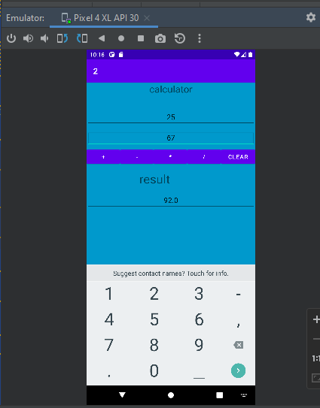

**Program 2**

Aim: Develop an application for a simple registration page using .xml file.

**Activity_main.xml**

<?xml version="1.0" encoding="utf-8"?>

<RelativeLayout

xmlns:android="http://schemas.android.com/apk/res/android"

xmlns:tools="http://schemas.android.com/tools"

android:layout_width="match_parent"

android:layout_height="match_parent"

tools:context=".MainActivity">

<TextView

android:id="@+id/idTVHeader"

android:layout_width="match_parent"

android:layout_height="wrap_content"

android:layout_marginTop="30dp"

android:gravity="center_horizontal"

android:padding="5dp"

android:text="Register Form"

android:textAlignment="center"

android:textColor="@color/purple_700"

android:textSize="18sp" />

<EditText

android:id="@+id/idEdUserName"

android:layout_width="match_parent"

android:layout_height="wrap_content"

android:layout_below="@id/idTVHeader"

android:layout_marginStart="10dp"

android:layout_marginTop="50dp"

android:layout_marginEnd="10dp"

android:hint="Enter UserName"

android:inputType="text" />

<EditText

android:id="@+id/idemail"

android:layout_width="match_parent"

android:layout_height="wrap_content"

android:layout_below="@id/idEdUserName"

android:layout_marginStart="10dp"

android:layout_marginTop="5dp"

android:layout_marginEnd="10dp"

android:hint="Enter Email"

android:inputType="textEmailAddress" />

<EditText

android:id="@+id/idphone"

android:layout_width="match_parent"

android:layout_height="wrap_content"

android:layout_below="@id/idEdUserName"

android:layout_marginStart="10dp"

android:layout_marginTop="50dp"

android:layout_marginEnd="10dp"

android:hint="Enter phone number"

android:inputType="number" />

<EditText

android:id="@+id/idPassword"

android:layout_width="match_parent"

android:layout_height="wrap_content"

android:layout_below="@id/idEdUserName"

android:layout_marginStart="10dp"

android:layout_marginTop="100dp"

android:layout_marginEnd="10dp"

android:hint="Enter Password"

android:inputType="textPassword" />

<Button

android:id="@+id/idBtnRegister"

android:layout_width="match_parent"

android:layout_height="wrap_content"

android:layout_below="@id/idPassword"

android:layout_marginStart="10dp"

android:layout_marginTop="20dp"

android:layout_marginEnd="10dp"

android:text="Register User"

android:textAllCaps="false" />

</RelativeLayout>

**Output**

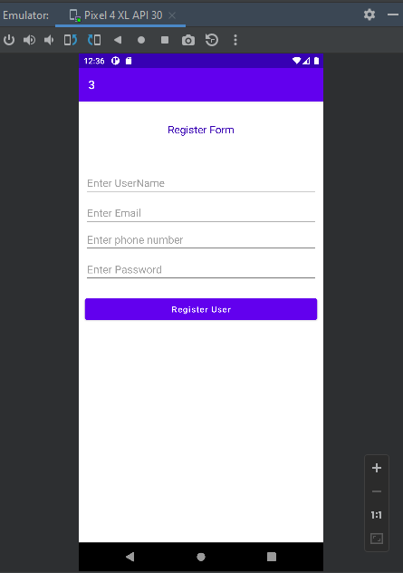

**Program 3**

Aim: Design an application for the login page using .xml file.

**Activity_main.xml**

<?xml version="1.0" encoding="utf-8"?>

<RelativeLayout

xmlns:android="http://schemas.android.com/apk/res/android"

xmlns:tools="http://schemas.android.com/tools"

android:layout_width="match_parent"

android:layout_height="match_parent"

tools:context=".MainActivity">

<TextView

android:id="@+id/login"

android:layout_width="match_parent"

android:layout_height="wrap_content"

android:layout_marginTop="30dp"

android:gravity="center_horizontal"

android:padding="5dp"

android:text="Login Form"

android:textAlignment="center"

android:textColor="@color/purple_700"

android:textSize="18sp" />

<TextView

android:layout_width="match_parent"

android:layout_height="wrap_content"

android:text="Username"

android:layout_marginTop="90dp"

android:layout_marginLeft="13dp"/>

<EditText

android:id="@+id/username"

android:layout_width="match_parent"

android:layout_height="wrap_content"

android:layout_below="@id/login"

android:layout_marginStart="10dp"

android:layout_marginTop="50dp"

android:layout_marginEnd="10dp"

android:hint="Enter UserName"

android:inputType="textEmailAddress" />

<TextView

android:layout_width="match_parent"

android:layout_height="wrap_content"

android:text="Password"

android:layout_marginTop="165dp"

android:layout_marginLeft="13dp"/>

<EditText

android:id="@+id/password"

android:layout_width="match_parent"

android:layout_height="wrap_content"

android:layout_below="@id/username"

android:layout_marginStart="10dp"

android:layout_marginTop="20dp"

android:layout_marginEnd="10dp"

android:hint="Enter Password"

android:inputType="textPassword" />

<Button

android:id="@+id/idBtnLogin"

android:layout_width="match_parent"

android:layout_height="wrap_content"

android:layout_below="@id/password"

android:layout_marginStart="10dp"

android:layout_marginTop="20dp"

android:layout_marginEnd="10dp"

android:text="Login" />

</RelativeLayout>

**Mainactivity.java**

package com.example.a1;

import androidx.appcompat.app.AppCompatActivity;

import android.os.Bundle;

import android.util.Log;

import android.view.View;

import android.widget.Button;

import android.widget.EditText;

import android.widget.Toast;

public class MainActivity extends AppCompatActivity {

@Override

protected void onCreate(Bundle savedInstanceState) {

super.onCreate(savedInstanceState);

setContentView(R.layout.activity_main);

EditText un =(EditText) findViewById(R.id.username);

EditText pw =(EditText) findViewById(R.id.password);

Button btn =(Button) findViewById(R.id.idBtnLogin);

btn.setOnClickListener(view -> {

String uname = un.getText().toString();

String passwd = pw.getText().toString();

if(uname.equals("ajce") && passwd.equals("123")){

Toast.makeText(this,"Login Success",Toast.LENGTH_SHORT).show();

}

Else{

Toast.makeText(this,"invalid username/password",Toast.LENGTH_SHORT).show();

}

});

}

}

**Output**

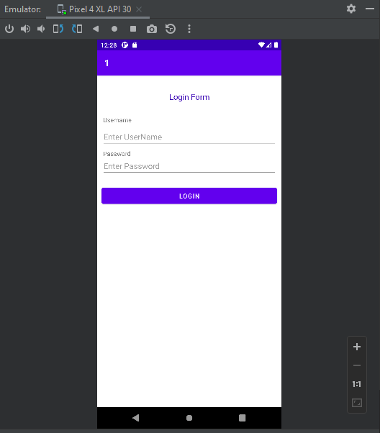

**Program 4**

Aim: Program to display the content of EditText in TextView on button Click.

**Activity_main.xml**

<?xml version="1.0" encoding="utf-8"?>

<LinearLayout xmlns:android="http://schemas.android.com/apk/res/android"

xmlns:tools="http://schemas.android.com/tools"

android:layout_width="match_parent"

android:layout_height="match_parent"

android:orientation="vertical"

tools:context=".MainActivity">

<EditText

android:id="@+id/edit1"

android:layout_width="300sp"

android:layout_height="wrap_content"

android:hint="Enter text here"

android:layout_marginTop="160sp"

android:layout_gravity="center"/>

<Button

android:id="@+id/btn_submit"

android:layout_width="wrap_content"

android:layout_height="wrap_content"

android:text="submit"

android:layout_marginTop="20sp"

android:layout_gravity="center"

android:backgroundTint="#9344F3"/>

<TextView

android:id="@+id/text_display"

android:layout_marginTop="35sp"

android:layout_width="wrap_content"

android:layout_height="wrap_content"

android:textSize="30sp"

android:layout_gravity="center"/>

</LinearLayout>

**Mainactivity.java**

package com.example.a4;

import androidx.appcompat.app.AppCompatActivity;

import android.os.Bundle;

import android.view.View;

import android.widget.Button;

import android.widget.EditText;

import android.widget.TextView;

public class MainActivity extends AppCompatActivity {

@Override

protected void onCreate(Bundle savedInstanceState) {

super.onCreate(savedInstanceState);

setContentView(R.layout.activity_main);

EditText editText = (EditText) findViewById(R.id.edit1);

Button button = (Button) findViewById(R.id.btn_submit);

TextView textView = (TextView) findViewById(R.id.text_display);

button.setOnClickListener(new View.OnClickListener() {

@Override

public void onClick(View v) {

textView.setVisibility(View.VISIBLE);

textView.setText(editText.getText().toString());

}

});

}

}

**Output**

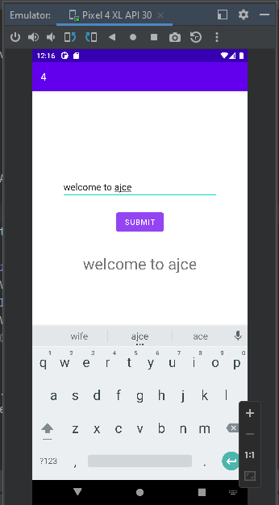

**Program 5**

Aim: Program to add two numbers and display the result in TextView on button click.

**Activity_main.xml**

<?xml version="1.0" encoding="utf-8"?>

<LinearLayout xmlns:android="http://schemas.android.com/apk/res/android"

xmlns:tools="http://schemas.android.com/tools"

android:id="@+id/activity_main"

android:layout_width="match_parent"

android:layout_height="match_parent"

android:orientation="vertical"

android:textAlignment="center"

android:background="@android:color/white"

android:weightSum="1">

<TextView

android:text="calculator"

android:layout_width="match_parent"

android:id="@+id/textView"

android:layout_height="30dp"

android:gravity="center_horizontal"

android:textColorLink="?android:attr/editTextColor"

android:textSize="24sp"

android:layout_weight="0.07" />

<EditText

android:layout_width="match_parent"

android:layout_height="wrap_content"

android:inputType="number"

android:ems="10"

android:id="@+id/editOp1"

android:textSize="18sp"

android:gravity="center_horizontal"

android:layout_marginBottom="5dp"

android:visibility="visible"

android:hint="first number"/>

<EditText

android:layout_width="match_parent"

android:layout_height="wrap_content"

android:inputType="number"

android:ems="10"

android:id="@+id/editOp2"

android:textSize="18sp"

android:gravity="center_horizontal"

android:elevation="1dp"

android:hint="second number"/>

<LinearLayout

android:orientation="horizontal"

android:layout_width="match_parent"

android:layout_height="wrap_content">

<Button

android:text="+"

android:layout_width="78dp"

android:layout_height="wrap_content"

android:id="@+id/btnadd"

android:layout_weight="0.03" />

</LinearLayout>

<TextView

android:text="result"

android:layout_width="332dp"

android:id="@+id/textView1"

android:layout_marginTop="10dp"

android:layout_height="50dp"

android:gravity="center_horizontal"

android:textColorLink="?android:attr/editTextColor"

android:textSize="30sp" />

<EditText

android:layout_width="match_parent"

android:layout_height="wrap_content"

android:inputType="number"

android:ems="10"

android:id="@+id/result"

android:textSize="18sp"

android:text="0.00"

android:gravity="center_horizontal" />

</LinearLayout>

**Main activity**

package com.example.a5;

import androidx.appcompat.app.AppCompatActivity;

import android.os.Bundle;

import android.view.View;

import android.widget.Button;

import android.widget.EditText;

import android.widget.TextView;

import android.widget.Toast;

public class MainActivity extends AppCompatActivity {

private EditText opr1;

private EditText opr2;

private Button btnadd;

private TextView txtresult;

@Override

protected void onCreate(Bundle savedInstanceState) {

super.onCreate(savedInstanceState);

setContentView(R.layout.activity_main);

opr1 = (EditText) findViewById(R.id.editOp1);

opr2 = (EditText) findViewById(R.id.editOp2);

btnadd = (Button) findViewById(R.id.btnadd);

txtresult= (TextView) findViewById(R.id.result);

btnadd.setOnClickListener(new View.OnClickListener() {

@Override

public void onClick(View v) {

if((opr1.getText().length()>0) && (opr2.getText().length()>0))

{

double oper1 = Double.parseDouble(opr1.getText().toString());

double oper2 = Double.parseDouble(opr2.getText().toString());

double result = oper1 + oper2;

txtresult.setText(Double.toString(result));

}

else{

Toast toast= Toast.makeText(MainActivity.this,"Enter The Required Numbers",Toast.LENGTH_LONG);

toast.show();

}

}

});

}

}

**Output**

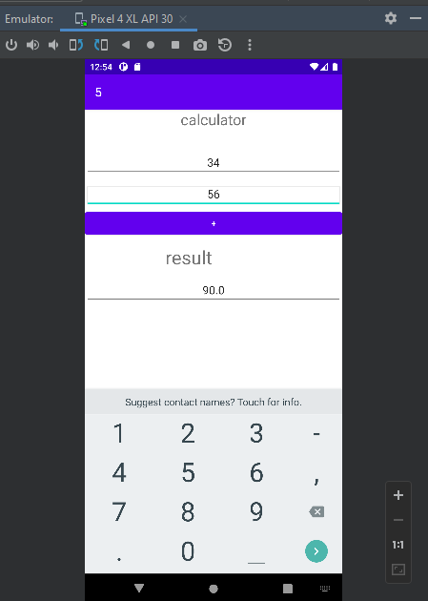

**Program 6**

Aim: Program to toast the content of EditText on button click

**Activity_main.xml**

<RelativeLayout xmlns:android="http://schemas.android.com/apk/res/android"

xmlns:tools="http://schemas.android.com/tools"

android:layout_width="match_parent"

android:layout_height="match_parent"

tools:context=".MainActivity"

android:id="@+id/rlVar1"

>

<EditText

android:id="@+id/editText"

android:layout_width="wrap_content"

android:layout_height="wrap_content"

android:hint="Enter text"

android:ems="10"

android:inputType="text"

android:layout_centerInParent="true"/>

<Button

android:id="@+id/showBtn"

android:layout_width="wrap_content"

android:layout_height="wrap_content"

android:layout_below="@+id/editText"

android:layout_centerInParent="true"

android:text="Show"/>

</RelativeLayout>

**Main activity**

package com.example.helloworld;

import androidx.appcompat.app.AppCompatActivity;

import android.os.Bundle;

import android.view.View;

import android.widget.Button;

import android.widget.EditText;

import android.widget.Toast;

public class MainActivity extends AppCompatActivity {

@Override

protected void onCreate(Bundle savedInstanceState) {

super.onCreate(savedInstanceState);

setContentView(R.layout.activity_main);

Button showBtn = findViewById(R.id.showBtn);

EditText editText = findViewById(R.id.editText);

showBtn.setOnClickListener(new View.OnClickListener() {

@Override

public void onClick(View v) {

Toast.makeText(getApplicationContext(), editText.getText().toString(), Toast.LENGTH_LONG).show();

}

});

}

}

**Output**

